

Soundbooth

Remove background noise
To remove steady background noise such as hiss or hum, use the Noise process.
- (Optional) Help Soundbooth better distinguish noise from desirable audio. In the Editor panel, select an area that contains only noise. Then choose Processes > Capture Noise Print.
- In the Editor panel, select the audio you want to clean up.
- Choose Processes > Reduce Noise.
- Set the following options:
Reduction
Specifies the amplitude of the noise floor. Audio that falls below this threshold is attenuated. Use lower values for audio with a wide dynamic range, such as classical music with loud and quiet passages. Use higher values for audio with a compressed dynamic range, such as pop music.
Reduce By
Determines how much to attenuate audio that falls below the noise floor.
Use Captured Noise Print
Distinguishes noise from desirable audio using the noise print you captured in step 1.
- Click Preview, and adjust settings as needed. To compare processed and original audio, click the power button .
- When you achieve the best-sounding results, click OK to process the audio file.
https://www.youtube.com/watch?v=krjhT8Ct68Q

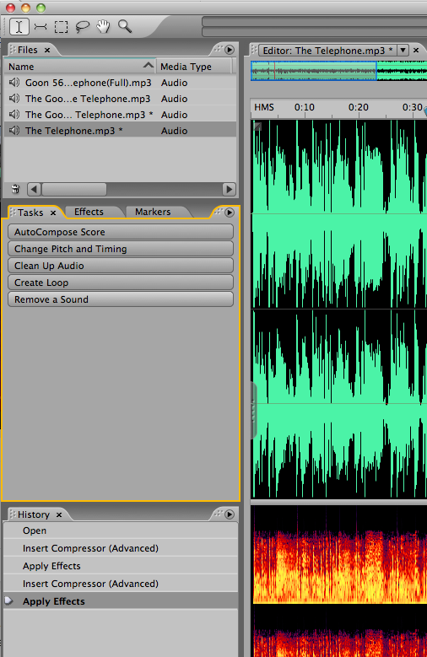
Remove a sound spectral display

Click on Remove a Sound

Select Frequency Selection tool
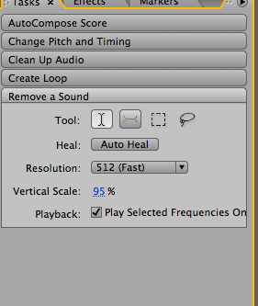

This portion here shows hum yellow
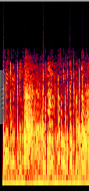
This portion looks like hum (Yellow)

Drag the selector tool over just this portion then reduce the volume of that and apply
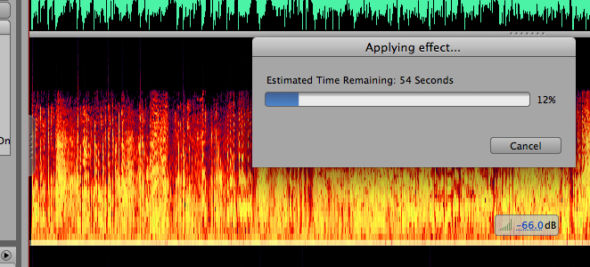
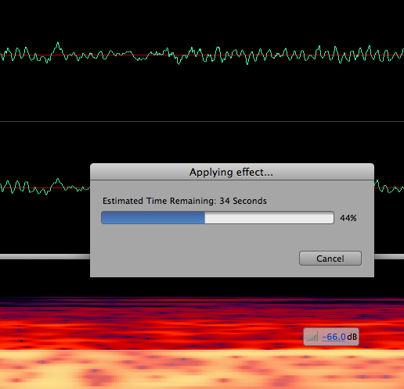
Before
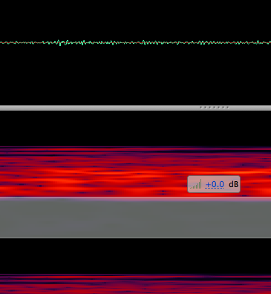
After


Need help just ask


